**GIS 8990: Research Problems in GIS Report**

**Project description**

This study involves a comprehensive spatial-temporal analysis of air quality within the Minneapolis metropolitan areas across time, including seasons of the year, days of the week, hours of the day. The collected data will first be meticulously cleaned and managed in a geospatial database. Second, we will employ spatial interpolation techniques to generate layers of air quality data for the entire study area, each correspond to a specific time periods. Using this dataset, we will review literatures and apply spatial-temporal analytical methods to uncover patterns and trends in air quality within the metro area. (Alternative) Exploring Relationship between Human Mobility and Air Quality Data In case of high-resolution temporal air quality data is not available, the project will use the weekly air quality summairy data to investigate the complex relationship between human mobility patterns and air quality. This analysis will involve data on human mobility, weather conditions, population distribution, employment density, land use, and traffic patterns. The goal is to identify correlations relationships between these factors and air quality outcomes as well as spatial patterns of air quality.

The method for both the projects follows the same systematic process. It begins with collecting air quality data, ensuring its cleanliness and organization. Relevant research papers will be reviewed to determine the most suitable analysis method. The advisor provides guidance through weekly meetings, and thorough documentation is maintained for future reference.

**Introduction**

What is air quality

Then focus on PM2.5

**Problem Statement**

In the Minneapolis metropolitan area, the pervasive concern of air pollution, particularly through PM2.5, poses a substantial environmental and public health challenge. The spatial and temporal variations in air quality within Minneapolis are influenced by diverse factors, including seasonal fluctuations, days of the week, and hourly variations. Understanding the intricate connections between human mobility patterns, weather conditions, population distribution, employment density, land use, and traffic patterns is pivotal in comprehending the dynamics of air quality. Notably, there is a conspicuous research gap pertaining to the specific impact of abnormal weather events, such as heavy rainfall or snowfall, on particulate matter dynamics in Minneapolis. Addressing this gap is essential for obtaining thorough understanding of the relationships between meteorological conditions and air quality, particularly during extreme weather events. Filling this research void is crucial for informing targeted air quality management strategies and policies tailored to the specific spatial-temporal patterns and trends observed in Minneapolis.

**Literature Review**

The concentration of fine particulate matter, or PM2.5, is a crucial metric in evaluating air quality, which is at the top of our list of concerns for a healthy environment. In recent investigations, researchers have delved into the multifaceted nature of PM2.5 in urban settings, probing into various contributing factors. Notable studies that provide insight into the ways in which transportation and economic development shape PM2.5 levels are Chen et al. (2017) and Guo et al. (2017), respectively. Furthermore, Guo et al. (2016)'s exploration of the influence of meteorological factors highlights how difficult it is to comprehend and control urban air quality.

The World Health Organization (WHO) updated its recommendations in 2021, reducing the suggested mean annual concentrations of various air pollutants to 15 μg/m³ for PM10, 5 μg/m³ for PM2.5, and 10 μg/m³ for NO2. According to Guan et al. (2016), severe and persistent air pollution has a major negative influence on human health in addition to endangering society's and the economy's ability to develop sustainably.

Anthropogenic activities and meteorological conditions are just two of the many variables that interact to affect air quality, and in particular, the elevated concentration of fine particulate matter (PM2.5). The objective of this literature review is to investigate the major variables that affect air quality, with an emphasis on the impact of weather events like rain and snow as well as cyclical patterns linked to heating systems and human mobility.

Guo et al. (2016) investigated the effects of rainfall on atmospheric particulate pollution using a distributed lag non-linear model (DLNM), highlighting the size-dependent impact on PM2.5 and PM2.5–10 in Guangzhou and Xi'an in 2013–2014. Based on particle size distribution, emission sources, and chemical compositions, the two cities' washout effects were found to differ significantly.

The Ziyue Chen et al. (2020) study provides a thorough analysis of the meteorological influences on PM2.5 concentrations throughout China, highlighting the importance of bidirectional PM2.5-meteorology interactions as key drivers and offering workable solutions for reducing PM2.5 pollution through meteorological means while highlighting the necessity of adapting to local conditions.

The comprehensive study by Duhanyan and Roustan (2011), which examines below-cloud scavenging by rain and its complex factors in the context of air quality modeling, emphasizes rainfall as a critical natural process for improving air quality.

Feng and Wang's (2012) study in Lanzhou, China, elucidated the profound impact of weather events on particulate matter concentrations, showcasing the severity of PM pollution during dust events, the dominance of wet scavenging in precipitation events, and the distinctive rise-and-decrease pattern in PM concentrations during cold fronts, providing valuable insights into the dynamic relationships between meteorological conditions and air quality in urban environments.

The research conducted by Jing et al. (2020) offers a comprehensive insight into the intricate interactions between meteorological factors and anthropogenic precursors, unveiling significant seasonal and regional variations in their effects on PM2.5 concentrations and underscoring the pivotal role of meteorological conditions, particularly temperature, as a major driving force.

Sun et al. (2019) utilize a chance-constrained stochastic Data Envelopment Analysis (DEA) model to investigate the intricate relationships between PM2.5 pollution days and meteorological factors and human activities in 13 cities in Jiangsu Province, China, revealing influential factors such as wind speed, precipitation, and population density, with variations across regions and risk levels, emphasizing the model's value in exploring essential data features.

Guo et al. (2017) find that the growth of logistics services, notably freight turnover, in Beijing initially positively impacts air pollution, suggesting the necessity of mitigating measures, while population growth has a minor effect, and GDP growth shows inconclusive trends, underlining the significance of addressing increased human activity-related air pollution.

Chen et al., (2017) investigates PM2.5 air pollution in a rural area of the North China Plain, finding severe pollution exceeding guidelines, with contributions not only from local and circumjacent areas but also from regional and long-range transport, emphasizing the need for coordinated emissions controls.

Wang et al. (2018) examine PM2.5 spatial variations in Chinese cities, emphasizing the need for tailored regional policies for effective air quality management, as elevation, vegetation, precipitation, temperature, and per capita GDP exhibit potentially offsetting effects, while local factors such as elevation and urban sprawl significantly impact PM2.5 concentrations.

Despite the wealth of literature on PM2.5 concentrations and influencing factors, there is a notable research gap concerning the specific impact of abnormal weather events, such as heavy rainfall or snowfall, on particulate matter dynamics. Further research in this direction could provide valuable insights into the intricate relationships between meteorological conditions and air quality, particularly in the context of extreme weather events.

**\*\*\*\*\*\*\*\*\*\*\*\*\*\*\*\*\*\*\*\*\*\*\*\*\*\*\*\*\*\*\*\*\*\*\*\*\*\*\*\* Pending**

The concentration of fine particulate matter, or PM2.5, is a crucial metric in evaluating air quality, which is at the top of our list of concerns for a healthy environment.. In recent investigations, researchers have delved into the multifaceted nature of PM2.5 in urban settings, probing into various contributing factors. Notable studies that provide insight into the ways in which transportation and economic development shape PM2.5 levels are Chen et al. (2017) and Guo et al. (2017), respectively. Furthermore, Guo et al. (2016)'s exploration of the influence of meteorological factors highlights how difficult it is to comprehend and control urban air quality.

In 2021, recognizing the urgency of mitigating air pollution, the World Health Organization (WHO) revised its guidelines, lowering the recommended mean annual concentrations for air pollutants, including PM10 to 15 μg/m³, PM2.5 to 5 μg/m³, and NO2 to 10 μg/m³ (World Health Organization, 2021). Guan et al. (2016) emphasize the consequential impact of severe and sustained air pollution on the sustainable development of the economy, society, and human health.

Anthropogenic activities and meteorological conditions are among the variables influencing air quality, particularly the elevated concentration of PM2.5. This literature review aims to investigate major variables affecting air quality, emphasizing the impact of weather events like rain and snow, along with cyclical patterns linked to heating systems and human mobility.

Guo et al. (2016) utilized a distributed lag non-linear model (DLNM) to investigate the effects of rainfall on atmospheric particulate pollution in Guangzhou and Xi'an during 2013–2014, revealing significant differences in washout effects between the two cities based on particle size distribution, emission sources, and chemical compositions.

The study by Ziyue Chen et al. (2020) comprehensively reviews meteorological influences on PM2.5 concentrations across China, highlighting bidirectional PM2.5-meteorology interactions as key drivers and suggesting practical approaches for mitigating PM2.5 pollution through meteorological means while underscoring the need for adaptation to local conditions.

The comprehensive study by Duhanyan and Roustan (2011), examining below-cloud scavenging by rain and its complex factors in the context of air quality modeling, emphasizes rainfall as a critical natural process for improving air quality.

Feng and Wang's (2012) study in Lanzhou, China, elucidates the profound impact of weather events on particulate matter concentrations, providing valuable insights into the dynamic relationships between meteorological conditions and air quality in urban environments.

The research conducted by Jing et al. (2020) offers a comprehensive insight into the intricate interactions between meteorological factors and anthropogenic precursors, unveiling significant seasonal and regional variations in their effects on PM2.5 concentrations, underscoring the pivotal role of meteorological conditions, particularly temperature, as a major driving force.

Sun et al. (2019) utilize a chance-constrained stochastic Data Envelopment Analysis (DEA) model to investigate the intricate relationships between PM2.5 pollution days and meteorological factors and human activities in 13 cities in Jiangsu Province, China, revealing influential factors such as wind speed, precipitation, and population density, with variations across regions and risk levels.

Guo et al. (2017) find that the growth of logistics services in Beijing initially positively impacts air pollution, suggesting the necessity of mitigating measures. Chen et al. (2017) investigates PM2.5 air pollution in a rural area of the North China Plain, emphasizing the need for coordinated emissions controls. Wang et al. (2018) examine PM2.5 spatial variations in Chinese cities, emphasizing the need for tailored regional policies for effective air quality management, as elevation, vegetation, precipitation, temperature, and per capita GDP exhibit potentially offsetting effects, while local factors such as elevation and urban sprawl significantly impact PM2.5 concentrations.

Despite the wealth of literature on PM2.5 concentrations and influencing factors, there is a notable research gap concerning the specific impact of abnormal weather events, such as heavy rainfall or snowfall, on particulate matter dynamics. Further research in this direction could provide valuable insights into the intricate relationships between meteorological conditions and air quality, particularly in the context of extreme weather events.

**\*\*\*\*\*\*\*\*\*\*\*\*\*\*\*\*\*\*\*\*\*\*\*\*\*\*\*\*\*\*\*\*\*\*\*\*\*\*\***

**Data**

Purple Air sensors within Minneapolis area:

3088, 5582, 11134, 21179, 43305, 54907, 61239, 77405, 85113, 99807, 101525, 108364, 110979, 113486, 128195, 142718, 142720, 142726, 142724, 142734, 142732, 142736, 142742, 142744, 142750, 142748, 142774, 142928, 142932, 143214, 143216, 143226, 143224, 143242, 143240, 143246, 143248, 143284, 143634, 143636, 143648, 143656, 143660, 143666, 143668, 143916, 143942, 145202, 145204, 145242, 145250, 145262, 145454, 145470, 145498, 145506, 145604, 157845, 157861, 157871, 157877, 157935, 161401, 166459, 168327, 174451, 174855, 176569, 182801, 183325, 186901, 188539, 193171, 193207, 194635, 196233, 198941

**Project Methodology**

**Data Analysis**

Two conditions while cleaning the data.

Average < 500 **µg/m³**

Highest < 1004 **µg/m³** (reported in Tiruppur, India)

During the data cleaning process, two critical conditions were applied to ensure the accuracy and reliability of the air quality information. Firstly, any sensors whose weekly average concentration of particulate matter (PM) exceeded 500 µg/m³ were flagged for further investigation and potential removal. This threshold was set to exclude outliers and extreme values that could skew the overall analysis. Secondly, a stringent criterion was implemented based on the highest ever reported Air Quality Index (AQI) value, with a limit set at 1004 µg/m³. This upper threshold was established in consideration of a specific incident reported in Tiruppur, India, as documented by aqi.in. Instances surpassing this threshold were subjected to scrutiny and, if deemed necessary, addressed in the data cleaning process to ensure the integrity and reliability of the dataset used for subsequent analyses.

**Table:** Sensors recording elevated pm2.5 levels (>500 µg/m³) or peaks exceeding 1004 µg/m³

|  |  |  |
| --- | --- | --- |
| **Season** | **Time** | **Sensors with average pm2.5_atm greater than 500 µg/m³ or any readings greater than 1004 µg/m³** |
| Winter | Jan-23 | [] |
| Spring | Apr-23 | [] |
| Summer | Jul-23 | [3088, 157871] |
| Fall | Oct-23 | [3088, 43305, 77405, 157845] |

**Some Events to be included in Analysis:**

**Other Events:** [Daily Data](https://www.dnr.state.mn.us/climate/historical/daily-data.html?sid=mspthr&sname=Minneapolis/St%20Paul%20Threaded%20Record&sdate=2010-01-01&edate=por)

**DNR Alerts:**  <https://www.dnr.state.mn.us/climate/journal/index.html>

1. "Big Mess" Snowstorm Clobbers Minnesota, January 2-5, 2023
2. Winter storm and heavy snow, February 21-23, 2023 (Maybe)
3. Spring Storm (Again), April 14-17, 2023
4. July 4 celebration (1-day / Drop)
5. Smoke Event of July 14, 2023
6. Intense Heat Wave, August 21-23, 2023
7. Welcome Rains Douse Minnesota: September 23-25, 2023
8. Twin Cities see biggest Halloween snowfall in over 30 years
9. Warm and Snowless December

1,3,5,6,8,9 — Priority — Add and drop events later after looking into trends

**Data should have:** hourly PM2.5, Temp, Humidity, Precipitation (daily average)

_____________  **Event**   ___________

2 days before                 2 days after

**Results:**

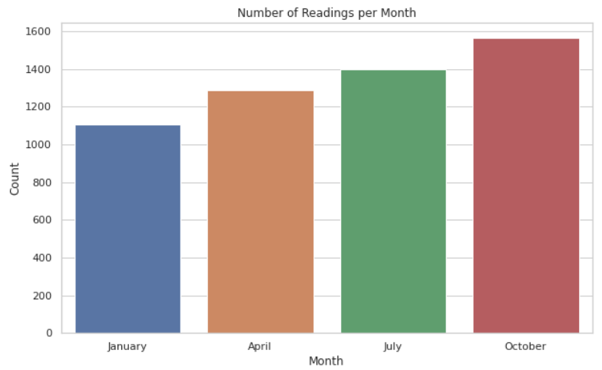

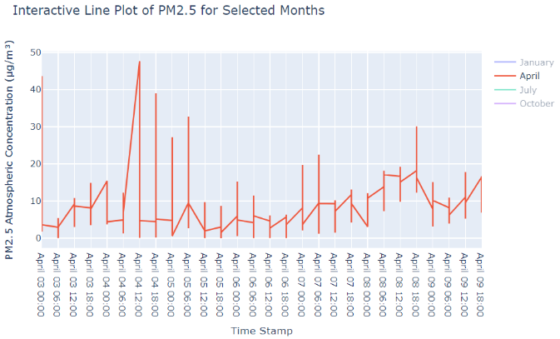

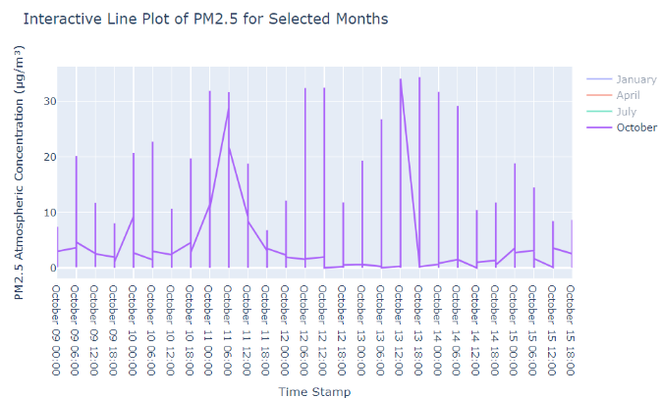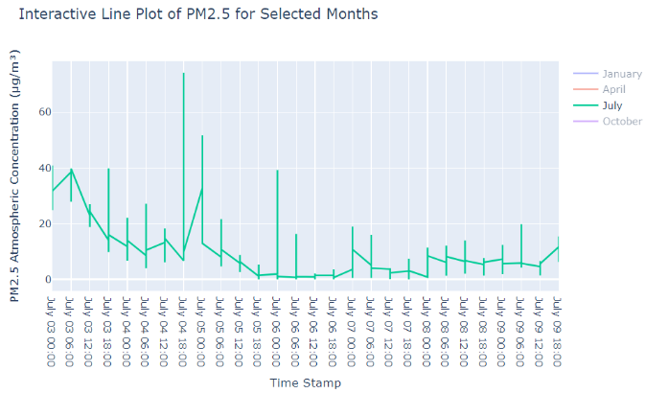

**Findings**

**Insights Gained from the Study**

**References**

**1.**     World Health Organization. (2021, November 15). Ambient (Outdoor) Air Pollution. Retrieved from<https://www.who.int/news-room/fact-sheets/detail/ambient-(outdoor)-air-quality-and-health>.

2.   Chen, Z., Chen, D., Zhao, C., Kwan, M. P., Cai, J., Zhuang, Y., ... & Xu, B. (2020). Influence of meteorological conditions on PM2. 5 concentrations across China: A review of methodology and mechanism. Environment international, 139, 105558.

3.      Guan, W. J., Zheng, X. Y., Chung, K. F., & Zhong, N. S. (2016). Impact of air pollution on the burden of chronic respiratory diseases in China: time for urgent action. The Lancet, 388(10054), 1939-1951.

4.       Guo, L. C., Zhang, Y., Lin, H., Zeng, W., Liu, T., Xiao, J., ... & Ma, W. (2016). The washout effects of rainfall on atmospheric particulate pollution in two Chinese cities. *Environmental pollution*, *215*, 195-202.

5.       Duhanyan, N., & Roustan, Y. (2011). Below-cloud scavenging by rain of atmospheric gases and particulates. *Atmospheric Environment*, *45*(39), 7201-7217.

6.       Feng, X., & Wang, S. (2012). Influence of different weather events on concentrations of particulate matter with different sizes in Lanzhou, China. *Journal of Environmental Sciences*, *24*(4), 665-674. ([Link](https://www.sciencedirect.com/science/article/pii/S1001074211608073))

7.   Jing, Z., Liu, P., Wang, T., Song, H., Lee, J., Xu, T., & Xing, Y. (2020). Effects of meteorological factors and anthropogenic precursors on PM2. 5 concentrations in cities in China. *Sustainability*, *12*(9), 3550. ([Link](https://www.mdpi.com/2071-1050/12/9/3550))

8.   Sun, R., Zhou, Y., Wu, J., & Gong, Z. (2019). Influencing factors of PM2. 5 pollution: Disaster points of meteorological factors. *International Journal of Environmental Research and Public Health*, *16*(20), 3891. ([Link](https://www.mdpi.com/1660-4601/16/20/3891))

9.       Guo, X., Shi, J., Ren, D., Ren, J., & Liu, Q. (2017). Correlations between air pollutant emission, logistic services, GDP, and urban population growth from vector autoregressive modeling: a case study of Beijing. *Natural Hazards*, *87*, 885-897. (Link)

10.   Chen, D., Liu, X., Lang, J., Zhou, Y., Wei, L., Wang, X., & Guo, X. (2017). Estimating the contribution of regional transport to PM2. 5 air pollution in a rural area on the North China Plain. *Science of the Total Environment*, *583*, 280-291. ([Link](https://www.sciencedirect.com/science/article/pii/S0048969717300608))

11.   Wang, S., Liu, X., Yang, X., Zou, B., & Wang, J. (2018). Spatial variations of PM2. 5 in Chinese cities for the joint impacts of human activities and natural conditions: A global and local regression perspective. *Journal of cleaner production*, *203*, 143-152. ([Link](https://www.sciencedirect.com/science/article/pii/S0959652618326003#bib3))